The case for integrated water, land and ecosystems management:
supporting multiple sustainable development objectives across the SDGs

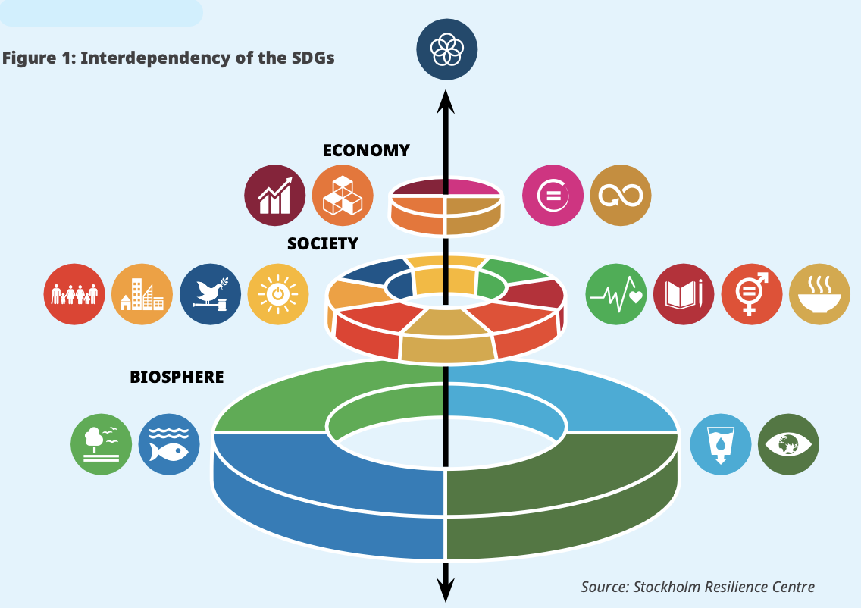
Why? The three pillars of sustainable development —economic, social and environmental— have been used for decades as a planning framework by governments, the United Nations, and other development partners. However, treating them as ‘separate’ pillars risks trade-offs between them. The interrelated nature of these pillars has become increasingly recognised, and there have been countless articles and reports on the interconnectedness of the Sustainable Development Goals. This has also been recognised to varying degrees within the main planning agreement between the UN system and the government in each country —the UN Sustainable Development Cooperation Framework— as well as in the reshaped institutional arrangements of UN Country Teams to ‘deliver as one’, with agency programmes coordinated by the Resident Coordinator's Offices.

However, integrating and coordinating work across the pillars, particularly in the implementation of the Cooperation Frameworks, remains a challenge. One aspect that is increasingly urgent to address in practice is how the environmental pillar underpins the social and economic pillars (Figure 1).

What? One concept driving much of the work of UN agencies and governments alike in this space is the recognition that natural resources —water, land, ecosystems and biodiversity— need to be managed at the river basin, or catchment, level, to support sustainable socio-economic development in each watershed. Integrated Water Resources Management (IWRM) can help governments do just that:

IWRM “is a process that promotes the coordinated development and management of water, land and related resources in order to maximise economic and social welfare in an equitable manner without compromising the sustainability of vital ecosystems.” This is achieved through coordinated policy and regulatory frameworks, management arrangements and financing.

SDG target 6.5 also calls for IWRM’s broad uptake: “By 2030, implement integrated water resources management at all levels, including through transboundary cooperation as appropriate.” In this light, IWRM already enjoys a long history of success and has been adapted for, tested and proven in a wide range of contexts around the world to ensure ecosystems and their services are feeding into sustainable socio-economic development. Indeed, political will to implement IWRM is strong within most countries’ water ministries in Africa, and many UN agencies and other organisations are working on IWRM-related projects and programmes. However, specific mention of IWRM in the design and implementation of many countries’ Cooperation Frameworks is conspicuously absent, representing a major lost opportunity. Furthermore, humanity is far from universal sustainable freshwater use, with estimates calling for a doubling of IWRM implementation to ensure reliable water supplies and continued development. UNEP, as the global custodian for SDG indicators 6.5.1 on IWRM implementation, 6.3.2 on ambient water quality, and 6.6.1 on freshwater ecosystems, has the mandate and expertise to support holistic programming in these areas, which in turn supports multiple development objectives across the SDGs.

How? Nature-based Solutions (NbS) and IWRM support multiple development objectives
A key aspect of that holistic programming will consist of Nature-based Solutions. In 2022, UN Member States adopted a resolution on Nature-based solutions for supporting sustainable development, which defines Nature-based Solutions (NbS) as “... actions to protect, conserve, restore, sustainably use and manage natural or modified terrestrial, freshwater, coastal and marine ecosystems which address social, economic and environmental challenges effectively and adaptively, while simultaneously providing human well-being, ecosystem services, resilience and biodiversity benefits”. Nature-based solutions for water management tend to require collaboration across, and provide benefits to, multiple sectors. As a result, integrated approaches, including IWRM, are critical in their implementation. To illustrate how crucial NbS and IWRM are to socio-economic development, the following subsections provide evidence on how both approaches utilise nature and ecosystems to contribute to a wide range of social and economic development objectives, and most, if not all, the SDGs. Further examples are provided in the “Evidence of success” reference document as part of this series.

Economy and Employment
Nature-based Solutions, or ‘green works’, tend to be labour-intensive, creating more jobs per $1 million USD invested than most other sectors, making them a key choice for policy makers attempting to address unemployment, especially in contexts of rapid rural-to-urban migration and young populations. For example, nature-based projects in India, South Africa and the United States created 155-500 jobs for every $1 million USD invested in watershed improvements and 265-626 jobs for every $1 million USD in afforestation, reforestation and desertification control. These investments lay the foundations for further economic opportunities. Just one example: a Dutch river restoration project led to 170 new jobs, a 10% increase in surrounding property values, and more than $1 billion dollars in annual revenue from tourism. Investing in nature makes sense for local economies and job creation. And, globally, the returns on investments in nature are projected to be tens of millions of jobs and hundreds of billions of dollars in additional GDP growth. Finally, with nature protection and the uptake of sustainable production practices, countries’ economic bases will diversify, with major gains in ecotourism and sustainable farming, forestry, and fishing, to name a few examples. Furthermore, three out of four jobs worldwide are water-dependent. Ensuring a clean and reliable water supply for all purposes is therefore essential to maintaining economic prosperity.

Pollution Reduction and Resilience to Flooding and Extreme Rainfall
Wetlands and forests are great at trapping water and runoff, and, in doing so, decreasing flooding and reducing pollution levels. For example, a recent publication found 492 case studies regarding the effectiveness of using nature to ensure water quality and quantity in Africa. The review found that floodplain wetlands and forest restoration tend to reduce flood risk and pollution levels.
Pollution: Wetlands in particular are excellent for reducing point and non-point source pollution. For example, the town of Bishop’s Falls in Canada wished to save costs on its water treatment facility, so it created the equivalent of 15 soccer fields of artificial wetlands mimicking their natural counterparts, and now the plant’s effluent averages below 10/10 mg/L TSS and BOD, far better than required by regulations. In Tanzania, Constructed Wetlands (CWS) were found to be effective at removing faecal coliform, suspended solids, and nitrates to meet national water standards and ensure potable water supplies for rural communities. Another study from Uganda showed that the city of Kampala’s Natete wetland was highly effective at reducing nutrient loads (pollution). Additionally, CWS can also be installed in key areas of farms to reduce chemical and sediment pollution entering rivers, lakes and streams. Several studies have documented the effectiveness of CWS in reducing a variety of pollution types with some key findings including removal rates of: (1) 70% for organic xenobiotics, (2) 75% - >98% for organic matter (BOD), (3) >75% for metals in general, (4) up to >80% for phosphorus, and (5) between 14%-90% for a range of pharmaceuticals.
Flood risk: Evidence from a large-scale project in China has demonstrated that forest and grassland restoration decreased soil erosion and thus sedimentation flows while lowering flood risk (Song et al. 2014; Gutiérrez Rodríguez et al. 2016, as cited here). Various studies have attempted to valuate these flood-reduction services, For example, one study showed that wetlands helped prevent $625 million USD in flood damages from 2012’s Hurricane Sandy in the United States (Narayan et al. 2017 as cited here). In terms of how many people benefit from ecosystems’ flood protection services, millions are protected by mangrove wetlands alone, either along coasts or riverways. Just in Vietnam, for example, one mangrove replanting project of 9,500 hectares is estimated to protect 2 million people from flooding.
One excellent way of encouraging wetland creation to generate these pollution- and disaster-risk-reduction benefits for society is the use of “stormwater credits” and “conservation easements.” For the former, a business or household that must pay fees to a utility for the water draining from their property is given a discount on that fee for installing wetlands, rain gardens, vegetated flood plains, etc. Regarding conservation easements, a property owner usually receives tax reductions in exchange for dedicating certain parts of their property to remain as forests or wetlands (an example from South Africa). See the Finance Toolkit for other options.

Resilience to Water Scarcity & Drought
One of the biggest threats to water supply is excessive water extraction, principally for agriculture, which uses 70% of all water supplies, combined with increasingly erratic rainfall due to climate change. This dual threat means the world’s freshwater sources are in trouble, negatively impacting food production, hydropower generation, shipping, and drinking water supplies, among other aspects of human society. Nature can help communities address this threat. Forests, for instance, create and maintain the necessary conditions for more rainfall (at least twice as much after air has passed over extensive vegetation), but clearing vegetation does the exact opposite, reducing overall water entering landscapes, meaning less is available for evapotranspiration and thus less rainfall is triggered. In total, some 40% of rain over land comes from evapotranspiration of water from plants. For those reasons, it will be essential to convert watersheds and landscapes back to forested and thus water-provisioning “natural infrastructure”, helping freshwater ecosystems and the water-dependent communities and economies that depend on those ecosystems to continue to thrive despite growing climate impacts and demand.
Agriculture, due to its water use and dependence on rainfall, is the most important actor in transforming watersheds and landscapes back into water-provisioning natural infrastructure. However, this does not mean that farming and livestock raising must suffer. Quite the opposite, ecosystem restoration and the widespread implementation of climate-smart or resilient agricultural practices can help improve water supplies, increase production and save producers and communities money in the process, in addition to generating a variety of investment opportunities.
Farmer Managed Natural Regeneration (FMNR) is one of the best ways of restoring watersheds and landscapes with proven results across many countries in Africa. In Ghana, men and women both perceived greater rainfall, more access to fruit, better livestock production and improved soil fertility (image above). In Ethiopia, FMNR beneficiary testimonials pointed to similar outcomes, including rain, good crop production, and water for livestock.
Like FMNR, agroforestry uses trees to help restore and protect watersheds. More variety in trees and crops means that more water is absorbed by the vegetation and soil and infiltrated into the underlying water table for storage, instead of simply running off the land. Certain combinations of trees and crops can capture up to 70% of rainfall while certain monocultures may only capture 6% to 16%. Scientists have shown that agroforests protect watersheds by ensuring this capture and infiltration of water into soils; without agroforests, one landscape studied in Bialo would see increased runoff, erosion and flooding and decreased water infiltration, affecting local water supply reliability. Finally, in Somalia, projects that used nature-based water-harvesting techniques (bunds, contour strips, balleys, etc. that are combined with FMNR and agroforestry practices) led to a major increase of 83% in water supplies for households (reducing water prices by 77%) and prevented erosion while improving pasture and water sources for livestock.
Water Funds (map with African examples, check out the Nairobi Water Fund) are a proven way for bringing together a wide variety of stakeholders to generate financing (based on payments for water provisioning services from ecosystems) for supporting sustainable land-use practices for watershed and landscape restoration to ensure reliable water supplies for city residents, water-dependent businesses, and farmers. See the Finance Toolkit (Table 1) for a list of impact investing opportunities for promoting climate- and water-smart production practices.
Cost Savings in Relation to Conventional Solutions
Nature-based Solutions are often more economical upfront than “conventional” grey infrastructure solutions, or they are within a short payback period, as they are largely self-regenerating and require less maintenance. Any policy maker should take this into account when making decisions on the allocation of funding, as their decisions will have a real impact on the prices their constituents pay for access to water, and, of course, money saved is money that can be invested in economic development.
One of the most famous examples comes from New York City, which paid land owners to leave forests intact (see “conservation easements” above) to ensure clean water supplies, costing the city ten times less than building and operating a water treatment facility.
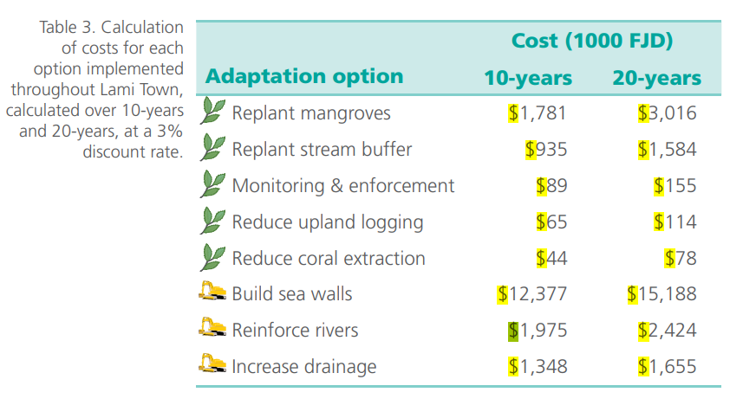
Another example from Lami Town, Fiji projected the costs of nature-based solutions (green leaves in image below) versus conventional solutions (dykes, reinforced river banks, and drainage systems) for coastal protection and flood-risk reduction. Natural solutions were significantly less expensive than conventional solutions. Additionally, an analysis from Vietnam suggested that restoring mangroves would cost US$166 per hectare in planting, capital and maintenance, but would create benefits of US$630 per hectare, including the avoided costs of sea dyke upkeep and revenue from timber and honey provisioning and fish-stock maintenance.
Another analysis calculated that restoration of the Skjern River floodplain in Denmark would cost US$44.2 million but provide net-present benefits of US$2.3 million in avoided water pumping to prevent flooding and US$84.6 million in additional co-benefits (hunting, fishing, recreational opportunities and biodiversity). Finally, CityAdapt, a UNEP project in Latin America, demonstrated that vegetated filtration ditches (an NbS) could capture the same amount of rainwater for US$3 million as that of a detention pond (essentially a small dam) costing US$22 million!

Energy
Ecosystems are crucial for ensuring reliable water supplies for hydropower production. Firstly, forests can reduce sedimentation loads (eroded soil) entering waterways by up to 44%, reducing dredging costs and improving hydroelectric power generation. Secondly, despite short-term gains in water flow from the deforestation of basins and landscapes surrounding dams (less trees to soak up water), decreases in water provisioning stemming from deforestation can outweigh those gains by up to 36% over the long run (and the average lifespan of a dam is 100 years), as less forest cover translates into less total rainfall falling in the basin or landscape. Finally, the combination of climate impacts and deforestation can greatly increase the variability in interannual power production, making power supply less reliable. Downstream consumers and businesses will suffer the consequences of deforestation in the form of higher prices and blackouts. A way to avoid these scenarios is the use of results-based payments (also called a pay-for-performance model) for watershed and landscape restoration and a shift to water- and climate-smart agricultural practices. With this approach, dam operators and utilities agree to fund restoration and production transitions by allocating a percentage of the resulting benefits (higher profits and lower expenses from avoided sedimentation, for example) derived from ecosystem restoration and agricultural transitions. Check out the Blue Energy Mechanism to learn more. Results-based Payments are highly adaptable and can be applied to nature-based solutions in the preceding section on cost savings as well.

Gender and Vulnerable Groups
Using nature also benefits women and vulnerable groups. In Somalia, a project using natural solutions and IWRM not only increased water supplies for beneficiaries but also reduced the time needed to fetch water from 3.5 hours to 20 minutes. This means that women and girls (most often tasked with collecting water) have more time for education and economically productive activities, and are less exposed to dangers such as sexual assault. Other benefits from adopting nature-based solutions and IWRM approaches are less tangible but still extremely important, including the empowerment of women and marginalised groups. A case in point: The UNEP CityAdapt project in Latin America uses a gender lens to identify where to best focus project activities for the greatest benefit across both sexes, and equal female participation is an integral part of project design and implementation. These approaches often produce cohorts of women and representatives of marginalised groups that are stronger self-advocates and greater participants in decision making on behalf of their communities.

Peace and Security
The UNEP IWRM “Wadi El Ku Catchment Management” project in Darfur, Sudan has led to peace between herders and farmers in the region by tying project support and benefits to the warring groups making peace with one another. Participatory project design and interventions using nature have since led to better pasture, more farm production, and reliable water supplies, cementing cooperation and building the trust and social cohesion needed for long-term cooperation underpinning IWRM. In total, some 200,000 people have benefited from the project’s tangible benefits and an environment of peace.

Partnerships
The process of engaging stakeholders to design and implement IWRM and nature-based solutions depends on and can strengthen partnerships across governments, the private sector, NGOs or philanthropic groups, small producers, and communities. The Green Climate Fund’s Dry Corridor project in Central America and the Caribbean is an excellent example of how silo-breaking partnerships encompassing banks, microfinance institutes, small and large farmers, NGOs, donors, and governments emerge from and underpin IWRM and NbS projects.

Further examples can be found in Evidence of Success: Nature-based Solutions for multiple development objectives.

UNEP and UNEP-DHI 2022. Rapid Needs Assessment Report: water resources management in UNSDCFs in Africa.
From South Africa’s 2020-2025 UN Sustainable Development Cooperation Framework, adapted from Stockholm Resilience Centre.
Global Water Partnership (GWP) 2000. Integrated Water Resources Management. Technical Advisory Committee, Background Paper No. 4.
UNEP (2021). Progress on Integrated Water Resources Management. Tracking SDG 6 series: global indicator 6.5.1 updates and acceleration needs. https://www.unepdhi.org/progress-on-integrated-water-resources-management-global-indicator-6-5-1-updates-and-acceleration-needs/
Three related publications: Nature Based Solutions for Water Management - A Primer, Green Infrastructure - Guide for Water Management, Nature-based Solutions to Emerging Water Challenges in the Asia-Pacific Region
Three related economic studies: The Economics of Biodiversity: the Dasgupta Review, The Economic Case for Nature, Valuing Nature Conservation.

