Finance Toolkit for Nature-based and Integrated Water Resources Management Solutions

The purpose of this reference document is to provide an overview of a wide range of financing options for integrated water, land and ecosystem management initiatives. It focusses on ‘non-conventional’ financing mechanisms.

‘Conventional’ Funding Sources

Multilateral and Bilateral Funding
The following documents can help to determine which multilateral and bilateral sources might be the most promising for climate-related NbS and IWRM actions in particular countries:
- Climate Finance Provided and Mobilised by Developed Countries in 2016-2020
- Joint Report on Multilateral Development Banks’ Climate Finance (2020)
- Multilateral Development Banks and Private Sector Engagement for Sustainable Development
- UNFCCC: Multilateral and Bilateral Funding Sources

Adaptation Funds
Check through the following list for opportunities to apply for grants to implement NbS and IWRM-focused projects:
- Adaptation Fund
- Global EbA Fund
- Least Developed Countries Fund
- Special Climate Change Fund
- Green Climate Fund
- Climate Investment Funds

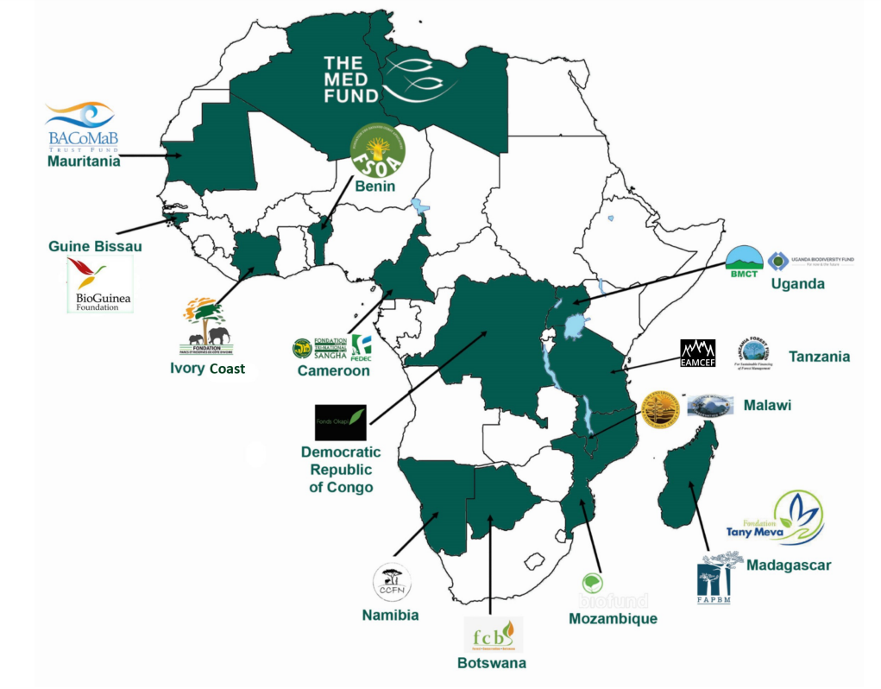
Environmental Funds (Conservation Trusts) in Africa
These are endowment funds that operate indefinitely, dedicating a certain portion of their total assets per year to protection of natural areas and species. They also fund sustainable development projects, climate action, and NbS. In August, 2022, a Pan-African Conservation Trust was established to raise $200 billion USD and allocate funding across the continent as needed. See Consortium of African Funds for the Environment (CAFE) for links to each fund shown on the map to the left (19 funds in 20 countries). There are additional examples in South Africa and Kenya.

Additional sources of environmental grants can be found on Environmental Grants, a grant database. For example, the Critical Ecosystems Partnership Fund invests in specific ecosystems (map), contributing to NbS for climate action and SDG achievement.

Transboundary Water Management Financing
- Funding and Financing of Transboundary Water Cooperation (UNECE)
- AIP Transboundary PIDA Water Investment Programme
- Cubango-Okavango River Basin Fund
- PIDACC Niger River Basin
- Zambezi Valley Development Fund

Impact Investing and Blended Finance
A Blended Finance structure can attract impact investments aimed at helping utilities, farmers, and businesses big and small transition to more sustainable production practices. These structures “soften” this transition by combining resources from philanthropy, governments, and the private sector. The combination of funding sources from different sectors allows for agricultural producers, for example, to access concessional or low-interest loans with long repayment periods to implement adaptation measures (riparian protection, agroforestry, drip irrigation, etc.) in their production practices. Credit and political risk guarantees from governments augment the pool of funds available by attracting private investors to non-conventional projects with major payoffs in terms of adaptation benefits and water conservation. Some examples of how Blended Finance approaches can promote water-positive change in the agricultural sector include The West African Initiative for Climate-Smart Agriculture and the Green Climate Fund’s Dry Corridor project in Central America and the Caribbean. Such impact investments can also be used to eventually receive sustainability certifications and thus higher prices for goods produced.

Further information on Blended Finance, and leveraging mechanisms, can be found in:
- Continental Africa Water Investment Programme (AIP): aiming to leverage US$1 billion SDG water-related investments per year by 2025 from bilateral, multilateral and private sources
- Blended Finance in the Water Sector
- Making Blended Finance Work for Water & Sanitation
- African Water Facility (part of AfDB)

Water and Climate-Smart Land Use
One of the biggest threats to freshwater supplies is excessive water extraction, principally for agriculture, which uses 70% of all water supplies, combined with increasingly erratic rainfall due to climate change, and sedimentation and chemical runoff into water supplies from the same farming areas. This triple threat endangers hydropower generation, food production, livestock raising, shipping, and drinking water supplies. Encouraging a shift to water- and climate-smart production practices and consumption patterns is therefore a basic requirement for ensuring continued economic growth and prosperity in the face of growing threats. More than an essential prerequisite for growth, this shift can actually generate attractive investment opportunities and be more economical than building, for example, a costly water pipeline or irrigation canal that requires expensive maintenance over decades. These impact investments can be paired with other mechanisms in this document to help convert entire watersheds and landscapes back to the natural, water-collecting and provisioning natural “infrastructure” that they used to be with benefits for farmers, potable water supplies, water-dependent businesses, and tourism-attracting wildlife.

Impact Investment Funds and Bonds
To attract private sector investments to shift to more sustainable land use in farming, livestock and forestry, some of the following conditions are helpful: business acumen, structuring of producers into associations (cooperatives) to reduce transaction costs, strong national and local enabling conditions in the form of competent institutions and corresponding supportive legal frameworks, and risk guarantees (contained in structure of many of the funds below). Some examples of investment funds and bonds include:
- Capital for Climate: Database of funds and mechanisms for NbS for perusal.
- Eco Business Fund: Focuses on sustainability in agriculture, fisheries/aquaculture, forestry, and tourism (Sub-Saharan Africa, Latin America and Caribbean). See publications.
- Moringa Fund: Combination of grants and impact investments for agroforestry projects (Sub-Saharan Africa, Latin America and Caribbean).
- Land Degradation Neutrality Fund: An impact investment fund blending resources from the public, private and philanthropic sectors to support achieving LDN through sustainable land management and land restoration projects implemented by the private sector (global).
- The &GreenFund: De-linking deforestation from major commodity supply chains. E.g. in exchange for conserving 5 ha of forest for every 1 ha of production, borrowers receive highly favorable loan conditions (global).
- Agri3 Fund: Credit enhancement, derisking tools, technical assistance for transition to sustainable practices (global).
- Forest bonds: IFC issues a Forests Bond and uses bond proceeds to support sustainable private sector forestry development.
- The Smallholder Resilience Fund (SRF): a blended investment fund using synchronized investments and technical assistance for high-value agricultural value chains for climate-resilient agricultural investments.
- Green Bonds for Climate Resilience: Publication with information on green bonds in various African settings. Bonds are created by governments, sold to investors, and proceeds fund shifts to climate and water-smart agriculture and/or NbS. Profits from the transition pay back the investors. Check out Climate Bonds for more information on this instrument for transitions.

Aquaculture
Aquaculture is a major contributor to water pollution and destruction of ecosystems vital for purifying and protecting water supplies. The following two funds can help projects invest in more sustainable aquaculture interventions.
- Aqua Spark: Invests in sustainable SME aquaculture businesses around the world (global).
- Eco Business Fund: Focuses on sustainability in agriculture, fisheries/aquaculture, forestry, and tourism (Sub-Saharan Africa, Latin America and Caribbean). See publications.

Microloans in Exchange for Sustainable Production Practices
Tying access to microloans in exchange for implementing sustainable production practices will be key for downscaling impact investments to small producers while granting access to financial services to more than a billion people on the planet with none whatsoever. Examples include MEBA (LAC and Africa, see manual), Greenfi, and Microsfere.

Microinsurance
Another way to encourage smallholders’ shift to sustainable production practices is with micro Bundled Index Insurance: This insurance scheme reduces producers’ vulnerability to drought and flooding with payouts once rainfall has either exceeded or fallen below certain parameters. With the assurance of insurance, producers are more likely to take out microloans (see above), for example, and invest in climate-smart practices and technology. See a Primer and example from Sudan.

Catchment protection/management financing mechanisms

Water Funds
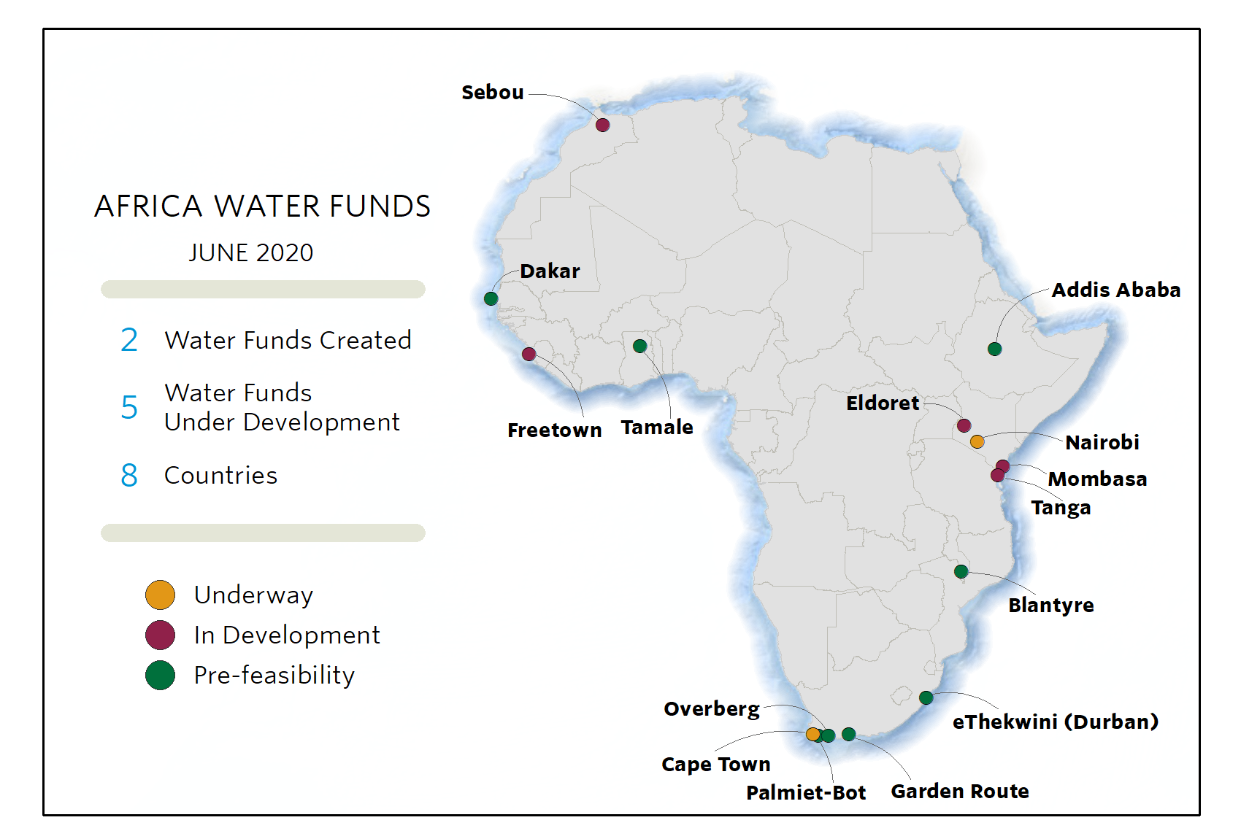
Water funds are essentially a market-based mechanism (it contains buyers and sellers) in which downstream water users pay upstream landowners and stakeholders for restoring and protecting ecosystems (forests, wetlands, paramo, etc.) crucial for ensuring reliable water supplies (see image below). Payments may consist of cash, in-kind transfers (technical assistance and equipment), or even guaranteed land-tenure. This mechanism is very well developed in that lessons learned from many existing water funds have helped streamline its replication all over the world, including in Africa (map right). Lessons on enabling conditions, stakeholder engagement, project design, implementation and adaptive management can be found in the TNC Toolbox. Finally, the Nature for Water Facility is a prime example of how those lessons are being harnessed to accelerate the formation of additional water funds and other watershed investments around the world.

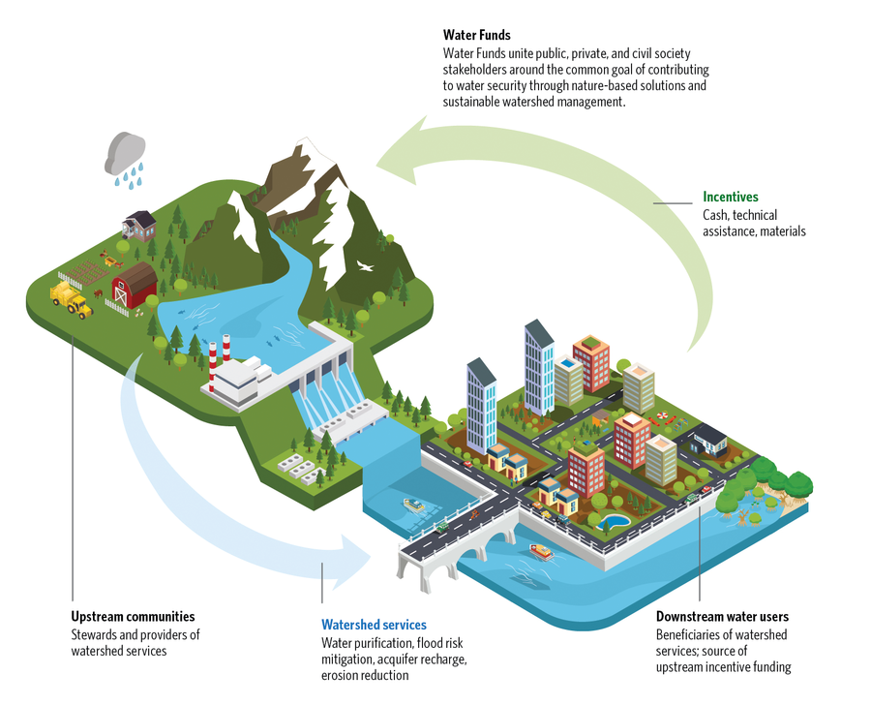
Image from the TNC Water Funds Toolbox

Pay-for-Success (Results-based-Payment) Models
Also referred to as Social Impact Bonds, this model uses capital from impact investors or grants to scale evidence-based programs and policies with payments made only with outcome achievement. See PFS and the Cloud Forest Blue Finance Mechanism (Brazil), which uses this model to pay for watershed forest restoration and conservation. In this case, when a hydropower company benefits from lower sediment dredging costs and higher and more regular water flow, it pays a percentage of its savings and higher profits to the entities restoring and protecting the forests responsible for those benefits. This model can be used in dozens of other ways, including to promote water supply and sanitation services in low-income areas (Kenya) or for the uptake of climate-smart agriculture (Sudan). This model is especially useful for developing-country governments that do not have all the upfront capital needed to invest in transitions to climate and water-smart practices all at once. Also, if the expected result is not achieved, the government is not responsible for payment, so it reduces the risk of wasting precious public funds.

Localized Finance Mechanisms for Pollution Control

Stormwater Credits
In exchange for installing water-harvesting equipment, green roofs, and storm or flood gardens on their property to decrease flooding, absorb pollution, and maintain a backup source of water for times of drought, owners receive a discount on their water and sewer bills. See Seattle Stormwater Credit. In South Africa, the cities of Cape Town, Tshwane, and Ethekwini, among others, already charge stormwater fees, making this a feasible mechanism for them.

Waste Banks
These banks incentivize decentralized waste collection and recycling by making cash or in-kind payments directly to collectors, or by extending small loans to those lacking access to finance with subsequent payments made in the form of collected plastic, glass, cardboard, etc. In removing trash and waste from communities, water pollution can be reduced and drainage systems will function better. See Waste4Change from Indonesia and Taka Bank from Kenya.

Decentralised Wastewater Treatment Systems (DEWATS)
Pay-for-poo/pee and circular economy models: See Kenya’s Sanergy and Sanivation, which could be applied to developing regions to provide revenue-generating opportunities in the form of mobile restrooms and subsequent fertilizer and fuel production, and wastewater-to-irrigation conversion (Egypt), which could be supported by water fees paid by farming operations.

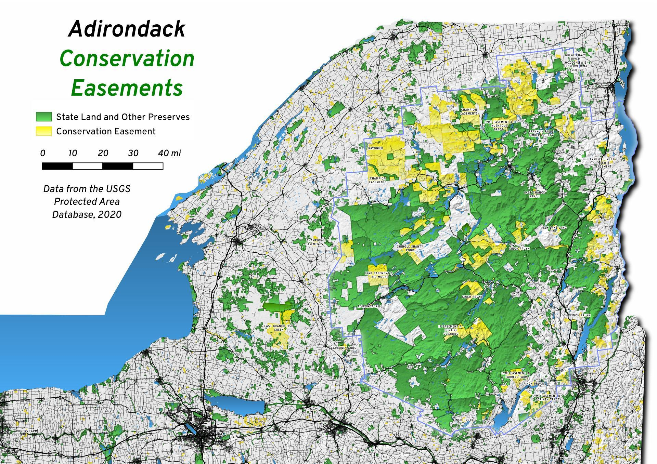
Fiscal and other Incentives for Water-Positive Land Management

Conservation Easement
A tax incentive or payment to convert private property into reserves to improve forest ecosystem provisioning of water water supplies, among other purposes. See Manual, NCED, and an example from South Africa. The image on the right shows how conservation easements in upstate New York have helped boost water supplies for downstream users in New York City.

Transfer of Development Rights (TDR)
TDR is an urban zoning technique that conserves land by redirecting development that would otherwise occur on the land (the sending area) to a receiving area suitable for denser development. The technique operates so that owners in the sending area can be compensated (lower property taxes, special privileges, for example) for land in the receiving area for their redirected development rights. TDR can thus ensure wetlands and forests, for example, are left intact to control flooding, absorb pollution, and prevent erosion and landslides on steep slopes. See Guide and TDR.

Carbon Offsets
Carbon emission offset payments are becoming easier to structure and access, and they should be seen as complements to other finance mechanisms and impact investments in forest conservation and restoration oriented toward water provisioning and purification. Rapid growth in voluntary carbon markets is especially promising. Gabon, for example, has just issued $2 billion in carbon credits to support a deforestation-neutral economy. Africa, with its vast forests under threat, is particularly ripe for these payments. The emerging Fund for Nature is helping establish a pipeline of offset projects in Africa and the Americas to receive payments from voluntary corporate emissions offsets. REDD+, Reducing Emissions from Deforestation and forest Degradation, continues to expand in Africa (see map), but it is a complicated and slow mechanism to implement. For that reason, various programs exist to assist countries in REDD+ efforts, including the Forest Investment Program in Burkina Faso, Democratic Republic of Congo, Congo Republic, Ivory Coast, Mozambique, Ghana, Cameroon, Zambia, Tunisia, Uganda and Rwanda, and the Forest Carbon Partnership with its REDD+ readiness fund ($400 million USD) and Carbon Fund ($900 million USD) using results-based payments to incentivize REDD+ uptake. One successful REDD+ in operation is the Wildlife Works Project in Kenya. Carbon credits from mangrove protection (“blue” carbon) are only just now emerging with the Mikoko Pamoja (also Kenya) project being one example.

Complex Finance Mechanisms & Instruments
The following tools require a suite of enabling conditions to function well, including strong and transparent institutions, effective management, and well developed monitoring systems. To date, most of these tools have been implemented in high or upper-middle-income countries, but the lessons learned from those experiences can contribute to the expansion of these useful mechanisms and instruments around the world.

Water Markets: Tradable Water Rights
Generally speaking, a science-based water “budget” for a region is set, and existing water users are allocated tradable (saleable or leasable) water-use permits within that budget. For users that can easily reduce their water consumption, unneeded permits can be sold or rented to users that cannot easily conserve water. The annual regional water budget is adjusted regularly to reflect changing climatic conditions such as drought. Australia and the United States’ water markets are the most well-known examples, but new water markets are also emerging in the South African Development Community (Namibia, Lesotho, Mozambique, South Africa, etc.) and Chile to address drought and scarcity. Read more about water markets here.

Payments for Coastal Protection
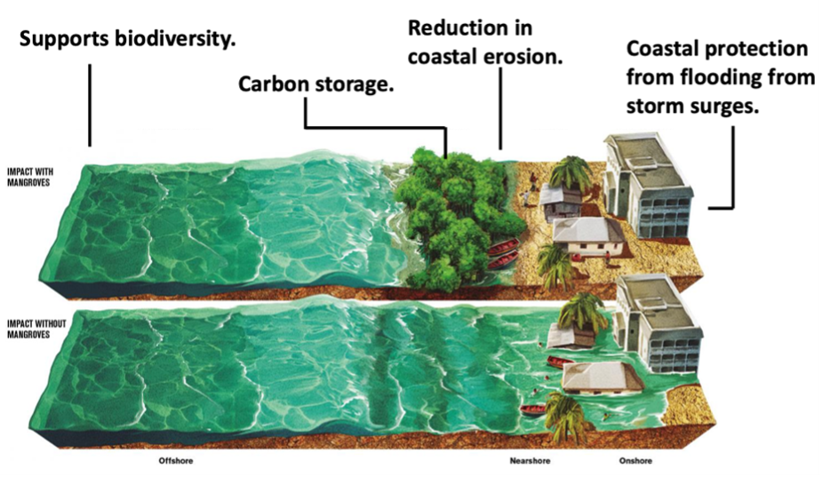
Stakeholders benefiting from coastal protection (reduced damages from erosion, storm surges and flooding) resulting from the restoration and/or conservation of mangroves, marshes, reefs, etc. pay a small fee for those services. The fee goes to those responsible for that restoration and conservation. See RISCO (combining coastal protection with insurance), Mikoko Pamoja (coastal protection and blue carbon credits in Kenya), and a UNDP primer on this mechanism. Coastal ecosystems also reduce saltwater intrusion into freshwater aquifers and agricultural soils.

Wetland Banking
Farmers and businesses restore wetlands to receive payments from businesses required to offset wetlands destroyed elsewhere for development purposes. See USDA and BioFund (Mozambique). Wetlands are crucial for reducing water pollution, decreasing the risk of flooding, and as a source of livelihoods for local communities.

Pollution Trading
A maximum level for a given watershed is first set. Farmers earn saleable credits by restoring and protecting riparian areas and wetlands. Those credits are then sold to actors not able to reduce their pollution levels. Overall, pollution in the watershed decreases. See Chesapeake Bay Foundation Water Quality Trading and a WRI report on such mechanisms around the world.

See Bird Friendly Coffee, Rainforest Alliance, Fair Trade, and FSC.
https://www.oecd.org/agriculture/topics/water-and-agriculture/
Image: Source
Image: https://www.theleafcharity.com/blog/benefits-of-mangroves-flood-protection

